|  |  |  |  |
| --- | --- | --- | --- |
| **Date:** | **18-05-2020** | **Name:** | **ROSHNI A B** |
| **Course:** | **TCS ION CAREER EDGE** | **USN:** | **4AL17EC080** |
| **Topic:** | **Communication to impress deliver presentations with impact,Develop softskills for the workplace.** | **Semester and section** | **6th sem**  **B-sec** |
| **Github repository:** | **Roshni_online** |  |  |

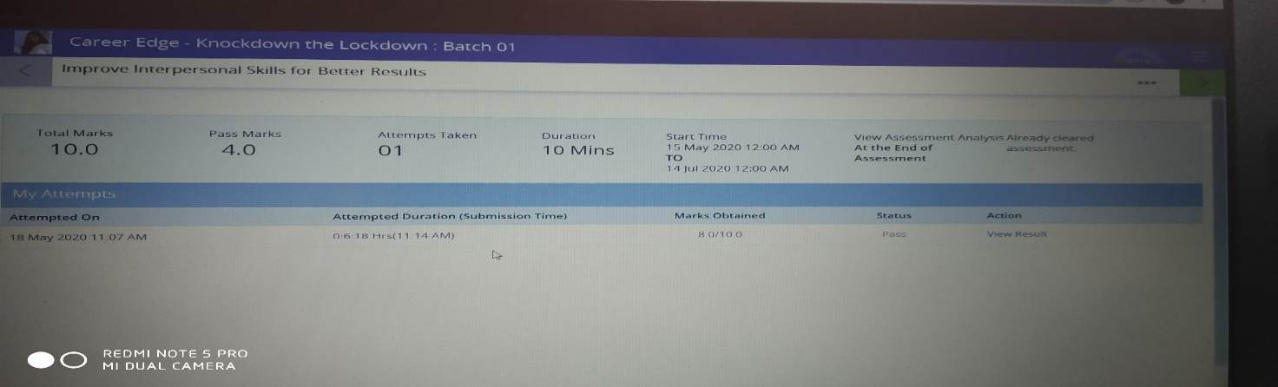

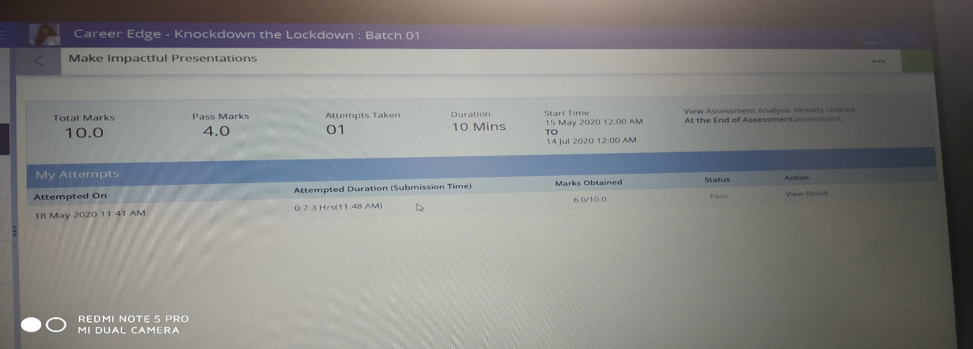

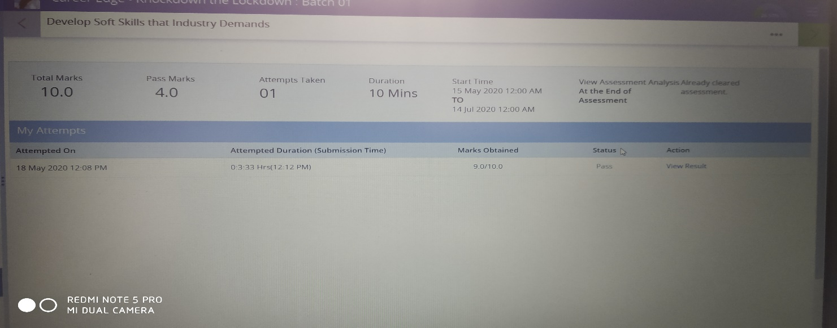

**COMMUNICATE TO IMPRESS:**

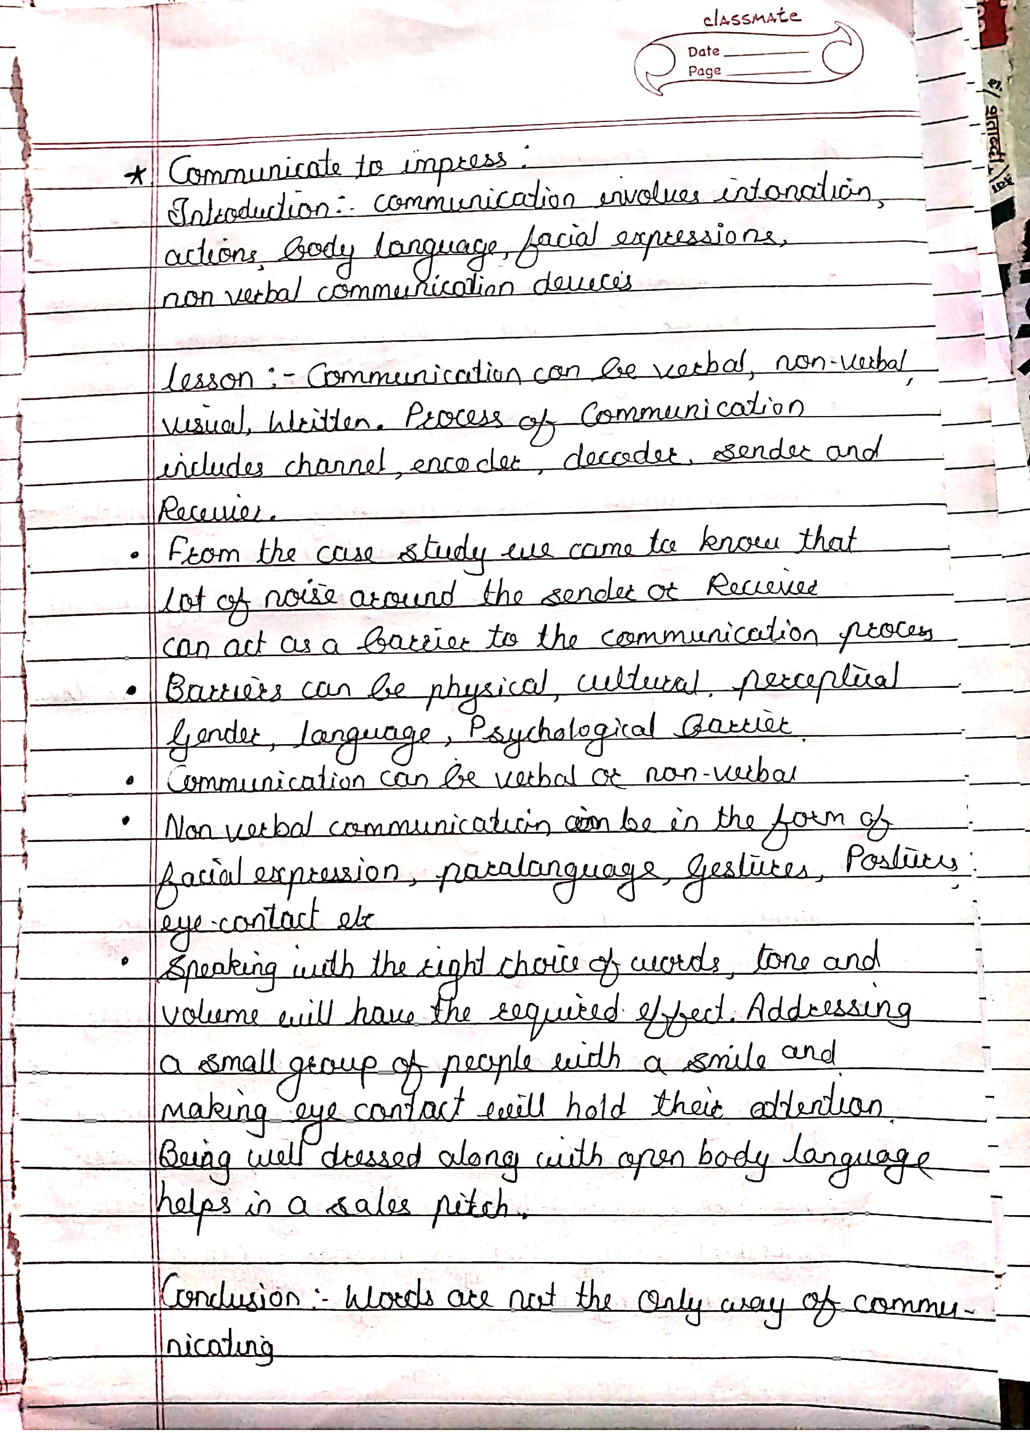

**DELIVER PRESENTATION WITH IMPACT:**

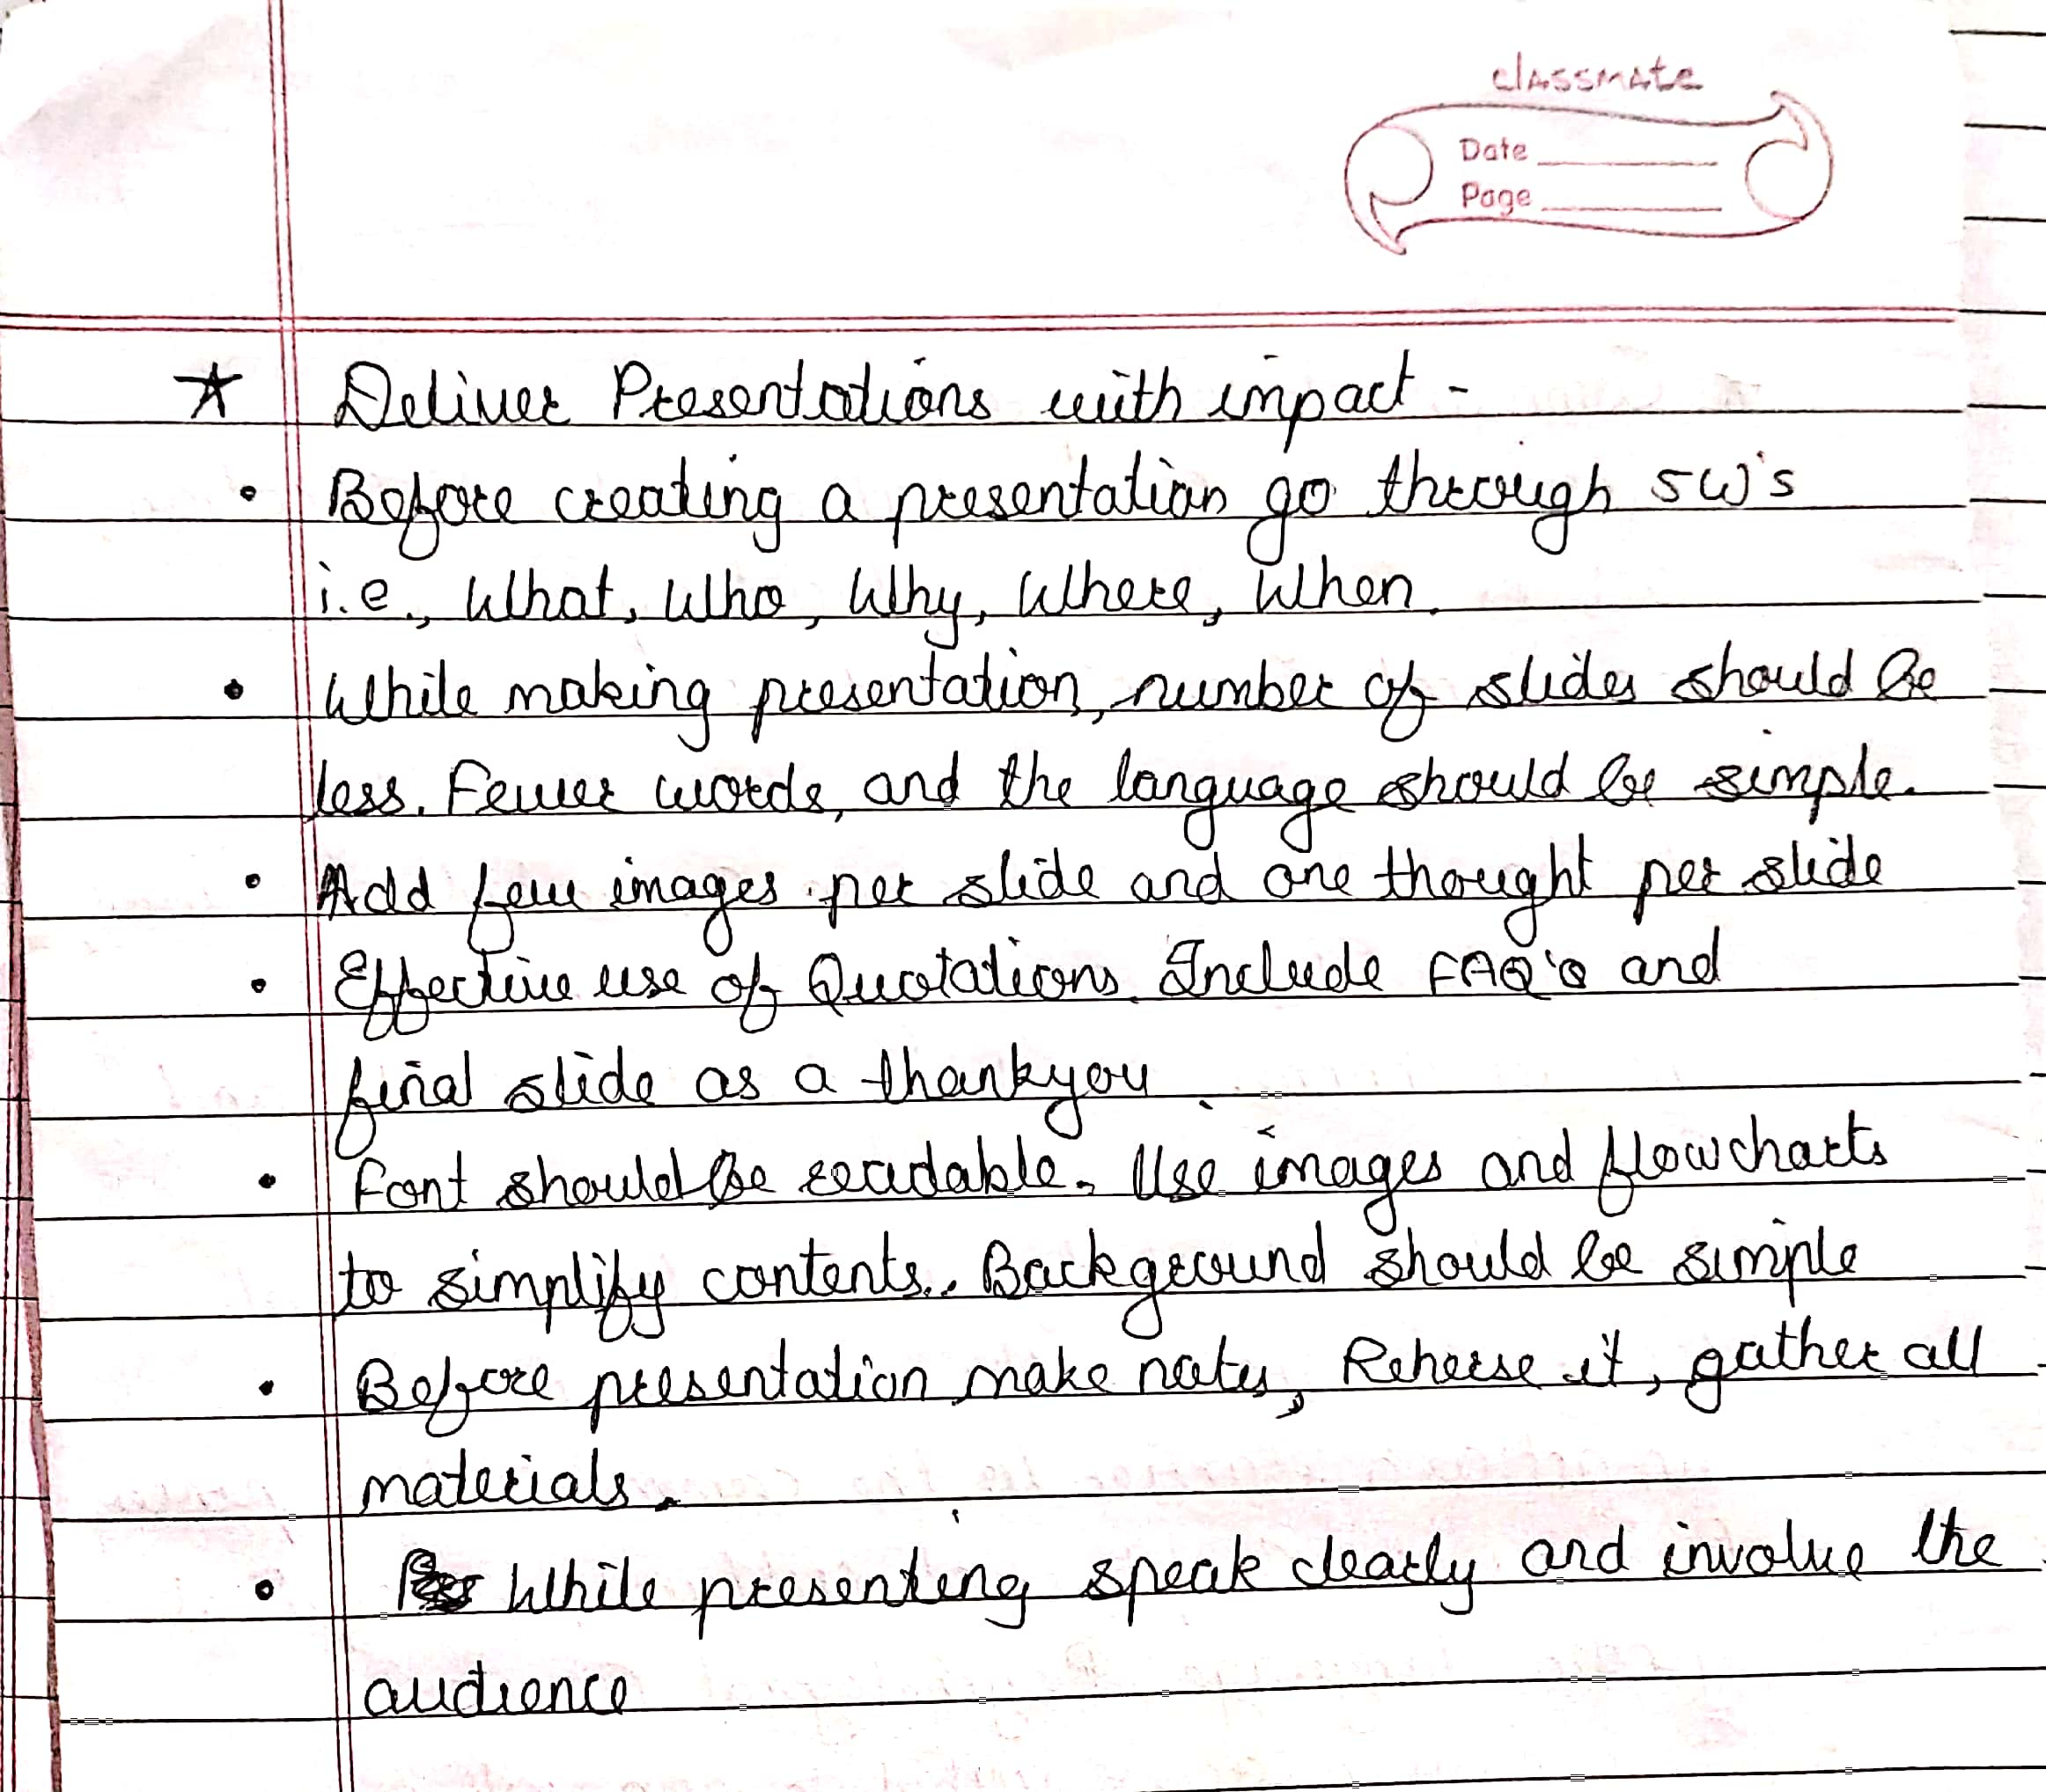

**DEVELOP SOFTSHILLS FOR THE WORKSLACE:**

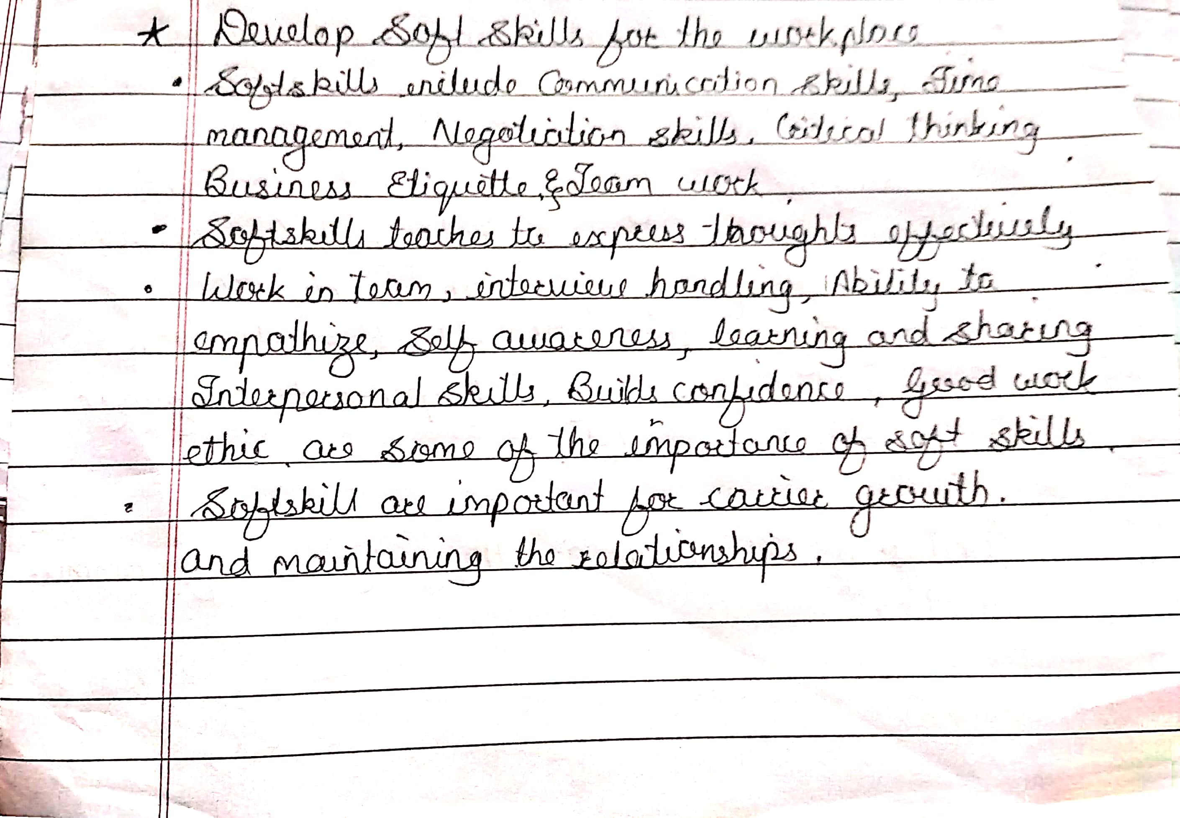

|  |  |  |  |
| --- | --- | --- | --- |
| **Date:** | **18-05-2020** | **Name:** | **ROSHNI A B** |
| **Course:** | **Python programming** | **USN:** | **4AL17EC080** |
| **Topic:** | **Introduction,basics:small program,data types,operation with data types,functions and conditions,processing user inputs,loops,building a program** | **Semester and section:** | **6th sem and B sec** |

